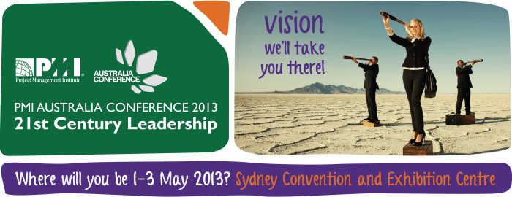

The Inaugural PMI Australia Conference – not long to go!
The PMI Australian Chapters have collaborated to present a conference like no other offered in Australia. One that will provide a platform for professionals, academics and community representatives to share knowledge, experience and professional camaraderie; whilst recognising and acknowledging professional excellence via the PMI Australia Annual Awards.

Read about the fantastic key note speakers we have lined up for you further in this issue, or visit www.pmi.org.au for all the information and latest updates on this not-to-be-missed event.

Oh, don’t forget to register. Registrations are open now, go to www.pmi.org.au and register today!

